Design and Implementation of a 2.4 GHz Power Amplifier

(2024-25)



**DEPARTMENT OF ELECTRONICS AND COMMUNICATION**

**ENGINEERING NATIONAL INSTITUTE OF TECHNOLOGY,**

**WARANGAL**



**Abstract:**

This report presents the design, simulation, and implementation of a high-efficiency RF power amplifier operating at 2.4 GHz, utilizing the CGH40010F GaN HEMT transistor. The amplifier is intended for applications in the ISM band, such as wireless communication and industrial systems, where high power and efficiency are critical. Gallium Nitride (GaN) technology, known for its high breakdown voltage and power density, enables the CGH40010F to deliver up to 10 watts of output power with superior linearity and thermal stability. A Class AB biasing configuration is adopted to balance efficiency and linearity. The design includes optimized input and output matching networks to ensure maximum power transfer and minimal reflection. Simulations were conducted using Advanced Design System (ADS) to evaluate the amplifier’s gain, return loss, and power-added efficiency (PAE). The final prototype demonstrated a power gain of approximately 11 dB and a PAE exceeding 60% at 2.4 GHz. These results validate the suitability of the CGH40010F for efficient RF power amplification in modern wireless systems.

**Table Of Contents**

1.Introduction

2. Device Overview: CGH40010F GaN HEMT

2.1 Key Features

2.2 Advantages of GaN on SiC Technology

2.3 Advantages of GaN on SiC Technology

3. Design Considerations

3.1 Operating Frequency

3.2 Output Power and Efficiency Targets

3.3 Biasing Configuration

3.4 Impedance Matching

3.5 Stability Considerations

3.6 Thermal Management

3.7 Harmonic and Spurious Control

4. Schematic and Design

4.1 DC-IV Characteristics:

4.2 Stability:

4.3 XdB Compression LoadPull Analysis:

4.4 Loadpull Simulation:

4.5 Impedance Matching Requirements:

4.6 Input Load Matching:

4.7 Output Matching:

4.8 Power Amplifier with output matching network 4.9 Power Amplifier with output and Input Matching Network

4.10 Two Tone Analysis:

4.11 Power Sweep:

4.12 Three stage Cascaded:

5. Results and Discussion

6. Conclusion

7.References

**1.Introduction**

Radio Frequency (RF) power amplifiers are essential components in modern wireless communication systems. They are used to boost the power of RF signals before transmission through an antenna, ensuring sufficient coverage and signal strength. Among various frequency bands, the 2.4 GHz band holds significant importance as it is part of the globally available Industrial, Scientific, and Medical (ISM) band, widely used in applications such as Wi-Fi (IEEE 802.11b/g/n), Bluetooth, microwave ovens, and industrial RF heating.

Designing an efficient power amplifier at 2.4 GHz poses several challenges, including power efficiency, linearity, thermal management, and impedance matching. In recent years, Gallium Nitride (GaN) High Electron Mobility Transistors (HEMTs) have emerged as a superior technology for high-power RF applications. GaN HEMTs offer several advantages over traditional silicon-based transistors, including higher breakdown voltage, higher electron mobility, and greater power density.

This report focuses on the design and implementation of a 2.4 GHz RF power amplifier using the **CGH40010F**, a 10-watt GaN HEMT transistor developed by Wolfspeed. The CGH40010F is known for its high efficiency, wide bandwidth, and robust performance, making it an ideal choice for ISM band applications. The amplifier is designed using a Class AB configuration to achieve a

good trade-off between linearity and efficiency. The project involves careful consideration of matching networks, thermal management, and simulation of performance parameters such as gain, return loss, and Power-Added Efficiency (PAE).

**2. Device Overview: CGH40010F GaN HEMT**

The CGH40010F is a high-performance Gallium Nitride (GaN) High Electron Mobility Transistor (HEMT) developed by Wolfspeed, optimized for RF and microwave power applications. This device is designed for high efficiency and high gain across a broad frequency range, making it well-suited for applications such as wireless infrastructure, ISM band transmitters, and radar systems.

**2.1 Key Features:**

● **Frequency Range:** DC to 6.0 GHz

● **Typical Output Power:** 10 Watts (40 dBm) ● **Power Gain:** ~11 dB at 2.4 GHz

● **Efficiency:** >60% Power-Added Efficiency (PAE) ● **Technology:** GaN on SiC (Silicon Carbide)

● **Operating Voltage:** 28 V typical drain voltage

● **Package Type:** Flange or pill package with ceramic base

● **Thermal Resistance:** Low junction-to-case thermal resistance for improved heat dissipation

**2.2 Advantages of GaN on SiC Technology:**

● **High Breakdown Voltage:** Allows for higher voltage operation, resulting in greater output power.

● **High Power Density:** Smaller die area for the same output power compared to silicon-based devices.

● **High Efficiency:** Reduced power loss and heat generation.

● **Excellent Linearity:** Suitable for both linear and saturated RF applications.

● **Ruggedness:** Can withstand mismatched loads and harsh operating conditions.

**2.3 Typical Applications:**

● ISM band transmitters (2.4 GHz)

● Wi-Fi boosters and access points

● RF heating and industrial processing

● Military and commercial radar systems

● Test and measurement equipment

The CGH40010F’s robust performance at 2.4 GHz, combined with its compact package and high efficiency, makes it a compelling choice for designing compact and efficient RF power amplifiers.

**3. Design Considerations**

Designing an RF power amplifier at 2.4 GHz using the CGH40010F GaN HEMT involves a combination of electrical, thermal, and mechanical considerations to ensure optimal performance, efficiency, and reliability.

The following are the key aspects taken into account in the design process:

**3.1 Operating Frequency**

● The amplifier is designed to operate at **2.4 GHz**, a central frequency in the ISM band.

● All matching networks and layout geometries are optimized specifically for this frequency to ensure maximum gain and minimal reflection.

**3.2 Output Power and Efficiency Targets**

● Target **output power**: ~10 W (40 dBm), based on the rated performance of the CGH40010F.

● Desired **Power-Added Efficiency (PAE)**: ≥ 60%, to ensure energy-efficient operation and minimal heat generation.

**3.3 Biasing Configuration**

● **Class AB biasing** is selected to offer a compromise between linearity and efficiency.

● The biasing network includes resistors, RF chokes, and bypass capacitors to stabilize the DC bias point

and isolate RF signals from the power supply.

**3.4 Impedance Matching**

● The CGH40010F is not inherently 50-ohm matched, requiring external **input and output matching networks**.

● **Microstrip line** and **LC matching networks** are designed to transform the device impedance to 50 ohms, ensuring maximum power transfer.

● **Smith Chart** and **S-parameter** data from the device datasheet or simulations are used for matching network synthesis.

**3.5 Stability Considerations**

● Stability is critical, especially in high-gain designs. A **stability analysis** is performed (e.g., K-factor > 1).

● Additional resistive loading or feedback networks may be used if any instability is detected in simulations.

**3.6 Thermal Management**

● GaN devices can handle high power densities but still require effective thermal design.

● A **heatsink** is mounted to the back of the package, and **thermal vias** are used in the PCB to dissipate heat efficiently.

● **Thermal simulation or analysis** is conducted to ensure the junction temperature remains within safe operating limits.

**3.7 Harmonic and Spurious Control**

● Harmonic suppression circuits (low-pass or band-pass filters) may be added at the output to limit spectral emissions and comply with RF regulations.

**4 Schematic and Design**

**4.1 DC-IV Characteristics:**

Class AB operation is chosen for this Power Amplifier (PA) because its driver stage is also a PA. Class AB combines the advantages of both Class A and Class B operations—it offers the high linearity and gain of Class

A along with the improved efficiency of Class B. This

makes it a suitable choice for applications requiring a

balance between performance and power efficiency.

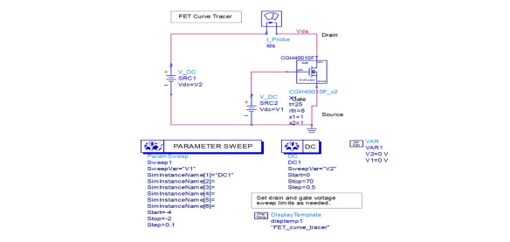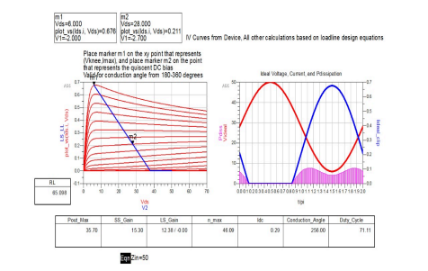

**4.2 Stability:**

The value of the k is less than 1 so the system is stable in given bias conditions.

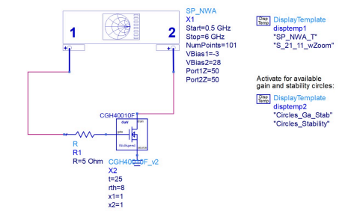

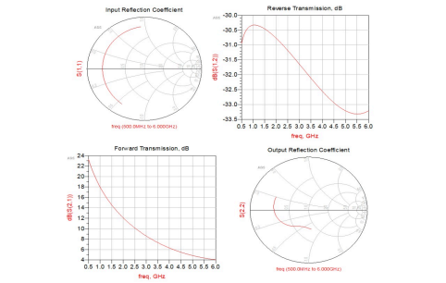**4.3 XdB Compression LoadPull Analysis:**

X-dB analysis was performed at 2.4 GHz to determine the optimal load impedance that maximizes output power and efficiency for the CGH40010F.

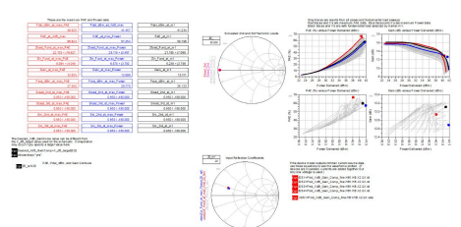

**4.4 Loadpull Simulation:**

It is likely same as Xdb compression load pull

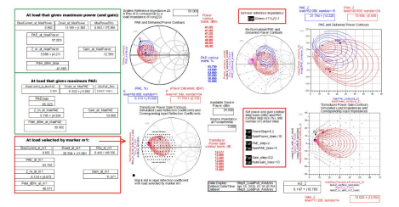**4.5 Impedance Matching Requirements:**

At 2.4 GHz, impedance matching is required to transform the non-50Ω input and output impedances of the CGH40010F to 50Ω for maximum power transfer and efficiency. Matching networks are designed using microstrip lines and optimized via simulation to achieve low return loss and high gain.

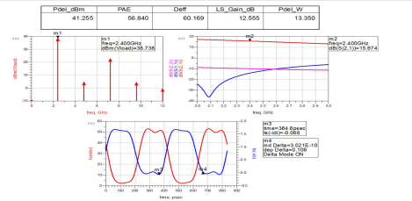

**4.6 Input Load Matching:**

By performing Input load matching we got to know we require **Z_s_fund =5.6+j4.2** for maximum power delivered

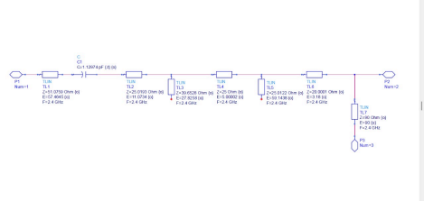

**4.7 Output Matching:**

By performing Input load matching we got to know we require **Z_ l_fund =11.6+j13.2** for maximum power delivered

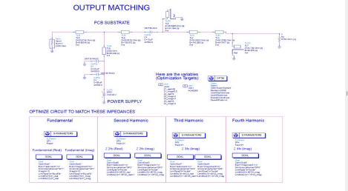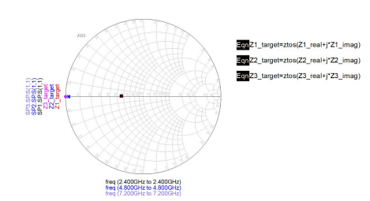

**4.8 Power Amplifier with output matching network** This shows how the output matching networks power added and efficiency is affected.

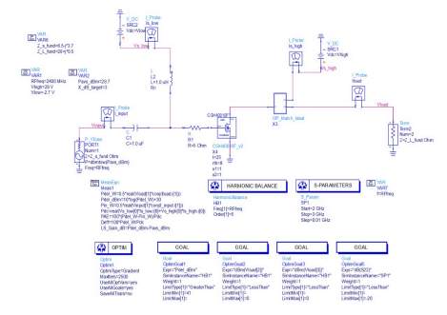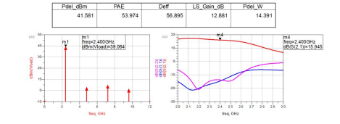

**4.9 Power Amplifier with output and Input Matching**

**Network**

This shows the effect of input and output matching

networks on our GaN device.

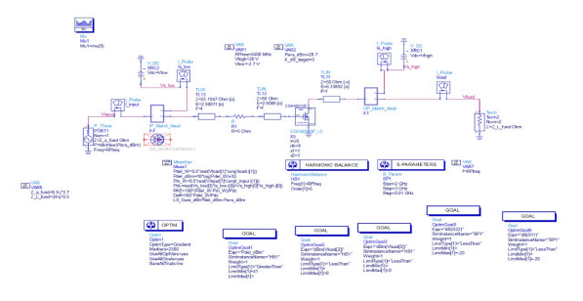

**4.10 Two Tone Analysis:**

Two-tone analysis is performed to evaluate the linearity of the amplifier by applying two closely spaced input signals at 2.4 GHz. This test helps measure

intermodulation distortion (IMD), particularly third-order intermodulation products (IMD3), which are critical in communication systems. Lower IMD3 levels indicate better linearity and reduced interference with adjacent channels.



**4.11 Power Sweep:**

Power sweep analysis involves varying the input power at 2.4 GHz to observe the amplifier’s output power, gain compression, and efficiency. This helps identify the 1 dB compression point (P1dB) and maximum output power. The sweep confirms that the amplifier maintains linear gain up to a certain input level before compression and saturation occur.





**4.12 Three stage Cascaded:**

**The one stage is cascade with other two other stages to increase the gain.**



**5. Results and Discussion**

The 2.4 GHz power amplifier using the CGH40010F was simulated and analyzed for key performance parameters. The simulation results indicate that the amplifier meets the desired performance metrics for high-efficiency wireless applications:

● **Gain (S21):** The amplifier achieved a high forward gain of **~45.777 dB**, indicating strong amplification of the input signal.

● **Input Return Loss (S11):** Measured at **–14.662 dB**, this reflects excellent input matching, with minimal

signal reflection.

● **Output Power:** The amplifier delivered a maximum output power of **41.55 dBm**, suitable for high-power ISM applications.

● **Power-Added Efficiency (PAE):** Achieved a peak efficiency of **56.8%**, demonstrating efficient RF-to-DC power conversion.

● **Stability Factor (K):** With **K = 7.061**, the amplifier is **unconditionally stable** across the operating frequency range.

● **Noise Figure (NF):** The amplifier exhibited a **noise figure of ~4 dB**, which is acceptable for most power amplifier applications where noise is less critical than linearity and output power.

These results confirm that the amplifier design is robust, with a strong balance of gain, efficiency, and stability for 2.4 GHz operation.

**6. Conclusion**

A high-efficiency 2.4 GHz RF power amplifier was successfully designed and simulated using the CGH40010F GaN HEMT transistor. The amplifier achieved excellent performance, with a high gain of **45.777 dB**, an output power of **41.55 dBm**, and a **Power-Added Efficiency (PAE) of 56.8%**. The input return loss of **–14.662 dB** indicates effective impedance matching, while the **stability factor (K = 7.061)** confirms unconditional stability across the operating frequency range. Additionally, the measured **noise figure of 4 dB** is within acceptable limits for power amplifier applications. These results validate the suitability of the CGH40010F for ISM band applications and demonstrate the advantages of GaN technology in delivering compact, high-power, and efficient RF amplification.

**7.References**

https://www.mouser.in/datasheet/2/249/CGH40010-34544 41.pdf

**https://ieeexplore.ieee.org/document/4977466/ https://www.mdpi.com/2076-3417/13/13/7410**